Cat Lovers versus Dog Lovers
Wild cats: solitary hunters, active at night.
Domestic cats: invisible during the day, occasionally engage in social activities or play with people, limited interest, abandon the game and wander away.
Cat people:12% more neurotic, 11% more open than dog people, appreciation for art, emotion, adventure, unusual ideas, imagination, curiosity, more likely to hold unconventional beliefs.
Cat owners: 1/3 more likely to live alone than dog owners, X2 as likely to live in an apartment or flat.
Cat owners: shy, more introverted, less sociable.
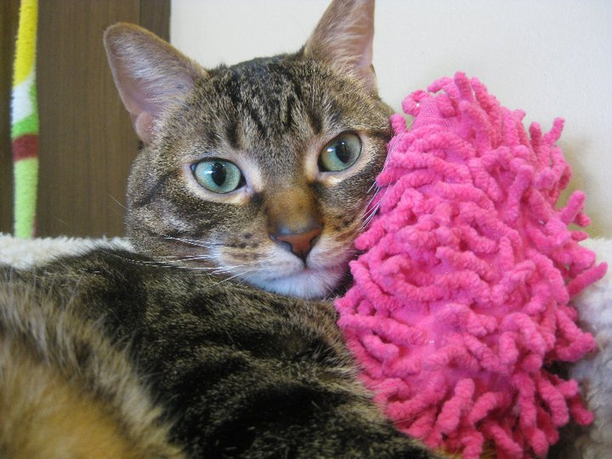

Wild canines: sociable pack animals, work in groups, active between dawn and dusk.
Domestic dogs: need for social interaction, want company or play, engage in play (e.g., fetching), human quits the game first.
Dog people: 15% more extroverted, 13% more agreeable, 11% more self-disciplined, complete tasks and aim for achievement, preference for planned rather than spontaneous behavior, have more conventional, traditional interests.
Dog owners: married, living in a house, and having children living in the home.
Dog owners: more social, interactive.
