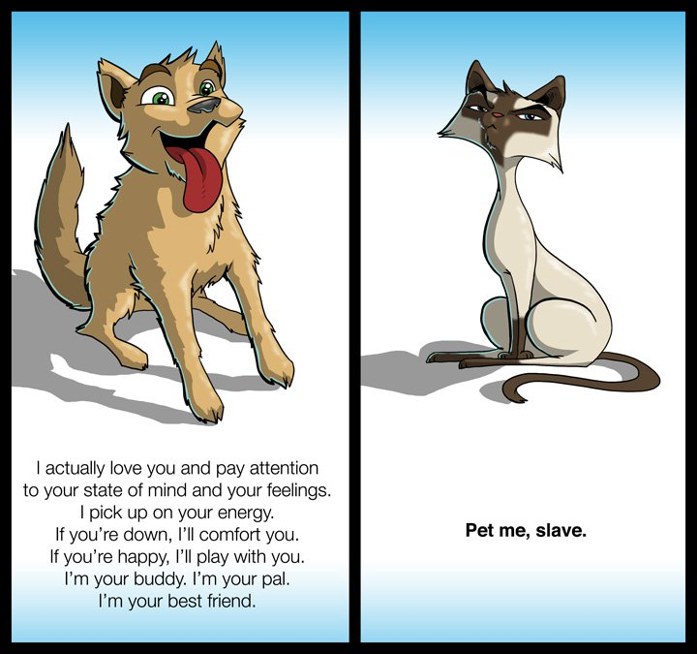**Cats versus Dog Cartoon**